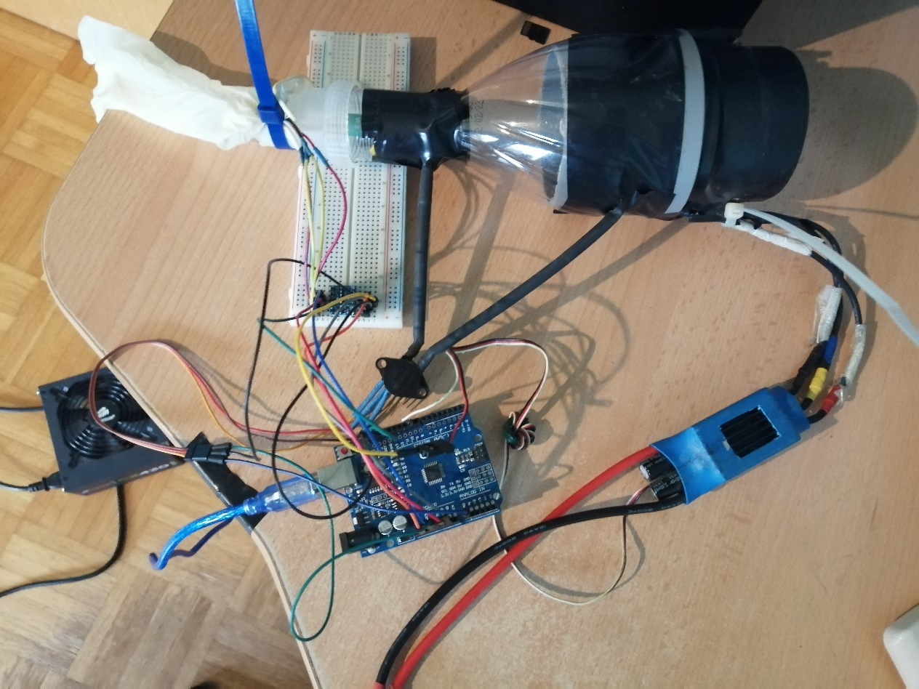

Arduino and ESC – connect ESC black to arduino GND. Connect ESC white to arduino DigitalPWM 9.

MPX5010DP – (search »MPX5010DP datasheet« on google). Connect pin on the right (on the pic) to arduino 5V. Middle pin goes to arduino GND. Pin on edge is signal and goes to arduino ANALOG IN A0 pin.

BMP280 – is a 3.3V module, so you need a 3.3 – 5V converter. Check datasheet, make sure to connect all BMP280 pins to LOW-VOLTAGE part of 3.3-5 converter. Also connect Arduino 3.3 and GND to LOW-VOLTAGE PART of 3.3-5v converter.

Connect arduino 5V and GND to HIGH-VOLTAGE part of converter. Connect the high-voltage signals to arduino SCK and SDA pins.

Converting pressure difference to flow:

https://en.wikipedia.org/wiki/Venturi_effect